Carl Patterson

Darryl Reeves

CS130 – Assignment 1

September 24, 2019

1) Plot (a sketch is fine) and label the following functions for 0≤n≤10 and0≤f(n)≤100 on a graph. (6 points)

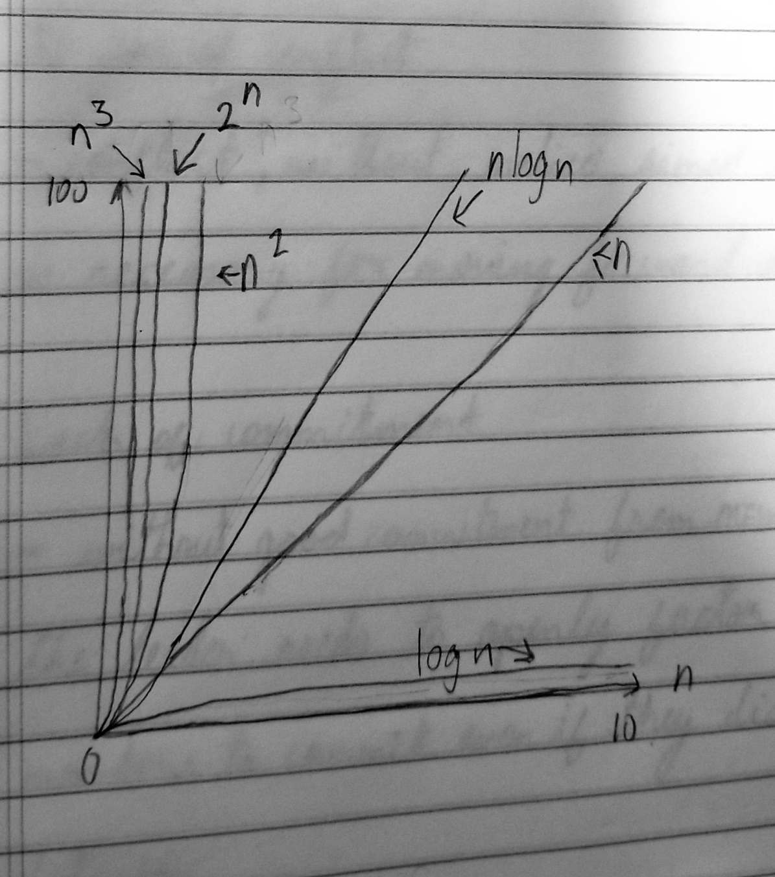

2) Determine the runtime complexity, T(n), for the following algorithm which calculates n! for positive values of n. Assume that the final (output) statement is a constant time operation. (5 points)

T(n) = 2n + 1

3) Determine the runtime complexity, T(n), for the following algorithm. (5points)

T(n) = 2n + 3

4) For each statement below, determine if the statement is True or False. (5points)

1. False
2. True
3. True
4. False
5. False

5) Provide the asymptotic runtime complexity, O(n), for each function below. (2 points)

1. n2
2. n5

6) Provide functions to represent T(n) and O(n). (7 points)

T(n) = 3n2 + 4n + 2

O(n) = n2

7) What is the asymptotic runtime complexity, O(n), of the code fragment be-low? (3 points)

O(n) = n3

8) Sort the following functions in order of asymptotic runtime complexity? (4points)

f2(n) = 10000000n

f1(n) = n0.9999999 log n

f4­(n) = n2

f3(n) = 1.000001n